**A CRM APPLICATION FOR WHOLESALE RICE MILL**

1. **Project Overview**

This project focused on Rice Mill CRM Application,designed to address complex rice mill operations into a user-friendly CRM system, enabling real-time data insights and efficient decision-making.The goal is to deliver a comprehensive solution by leveraging Salesforce. Through this project, we aim to enhance **operational efficiency** by automating daily tracking and reporting of rice production, sales, and revenue, saving time and reducing manual effort. It improves **user experience** with intuitive dashboards and ensures **data accuracy** through validation rules and real-time calculations, empowering informed decision-making and supporting the long-term goals of wholesale rice mills.

**2. Objectives**

**Business Goals**

1. Streamline Operations: Automate daily rice production, sales tracking, and revenue reporting.
2. Enhance Data Insights: Provide real-time analytics for better decision-making and resource allocation.
3. Improve Security and Access Control: Implement role-based permissions for secure and efficient data management.
4. Optimize Customer Relationships: Identify key buyers and improve engagement through tailored insights.

**Specific Outcomes**

1. Key Deliverables:
   * Automated daily reports summarizing production, sales, and revenue trends.
   * Dashboards visualizing metrics like rice types sold and high-value customers.
   * Accurate payment calculations using formula fields.

1. Performance Metrics:
   * 100% accuracy in daily sales and revenue reports.
   * Full implementation of role-based access control for owners, employers, and workers.
   * Reduction in manual errors through validation rules by at least 90%.
2. Adoption and Results:
   * Achieve user satisfaction above 85% within the first three months.
   * Increase operational efficiency by reducing time spent on manual calculations and reporting.

1. **Salesforce Key Features and Concepts Utilized**

In the Rice Mill CRM Application project, key Salesforce features and concepts include:

**Custom Objects**:

Used for tracking data like Rice Sales, Suppliers, and Workers.

**Create Supplier,Rice Mill,Rice Details and Consumers Object**

Salesforce objects are database tables that permit you to store data that is specific to an organization. What are the types of Salesforce objects

**To create Supplier object:**

From the setup page >> Click on Object Manager>> Click on Create>>Click on Custom Object.

1. Enter the label name
2. Plural label name
3. Enter Record Name Label and Format

* Record Name
* Data Type>>Text

Click on Allow reports and Track Field History and allow search

Allow search >> Save.

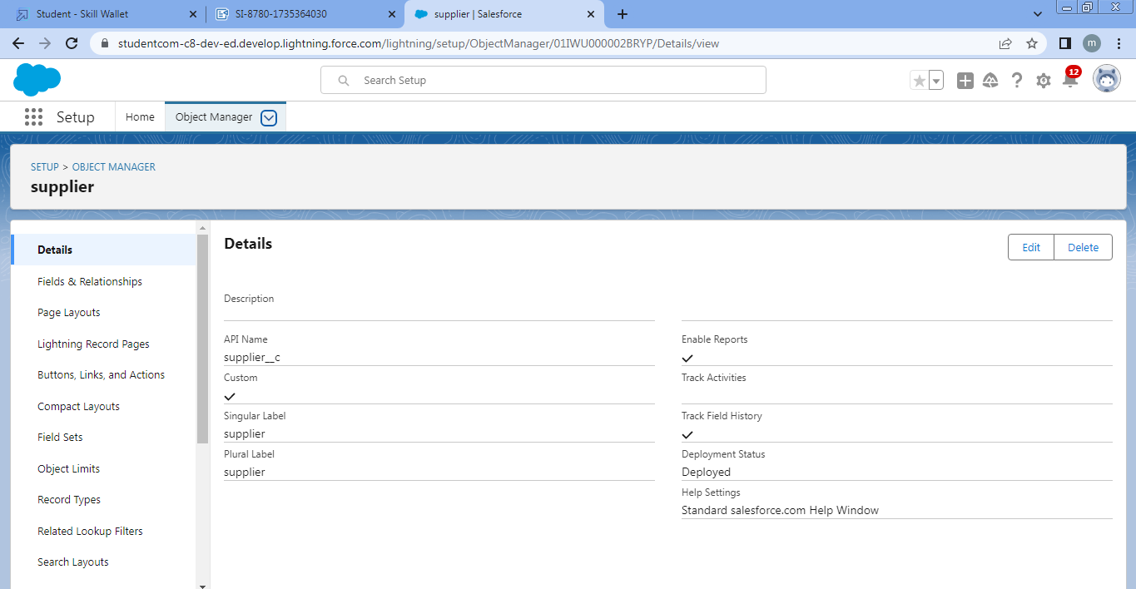

**To create Rice mill object:**

From the setup page >> Click on Object Manager>>Click on Create >> Click on Custom Object.

Enter the label name>>rice mill

Plural label name>> rice mills

Enter Record Name Label and Format

Record Name >>

Data Type >> Auto Number

Display Format >> rice-{000}

Starting number >> 1

Click on Allow reports and Track Field History, Allow Search and Save.

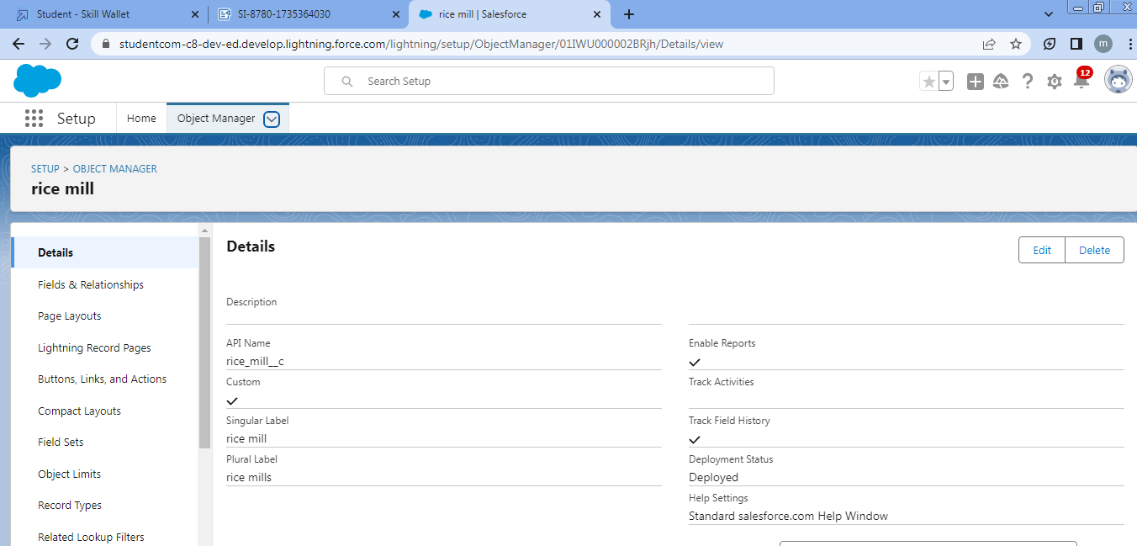

**To create Consumer object:**

Use these display format for the  consumer

label name >> consumer

Plural label name >>  consumers

Display Format >>  consumers-{000}

Starting number >> 1

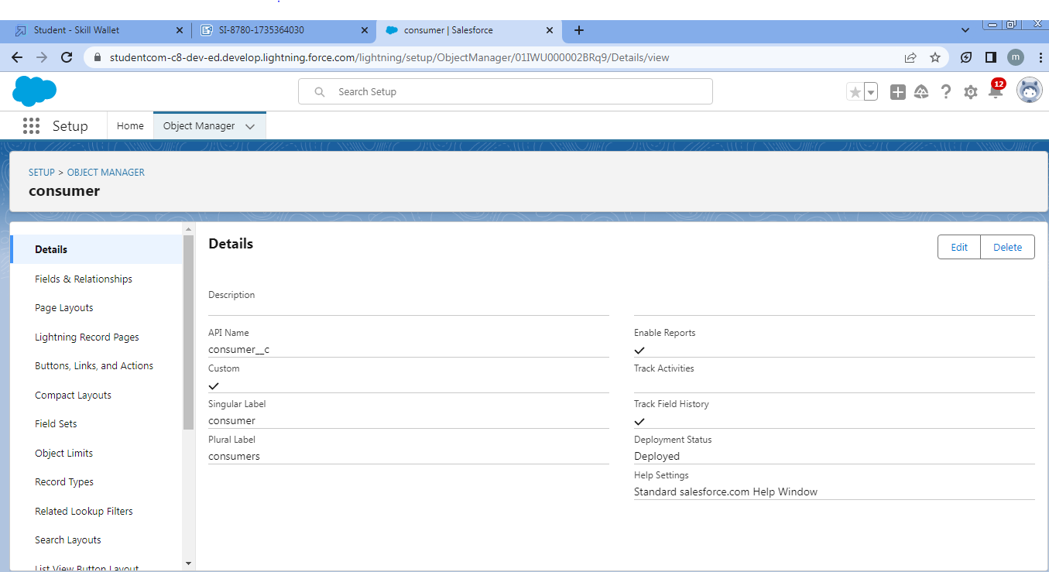

**To create Rice details object :**

Use these display format for the rice details

label name >> rice details

Plural label name >> rice details

Display Format >> rice-{000}

Starting Number >>1

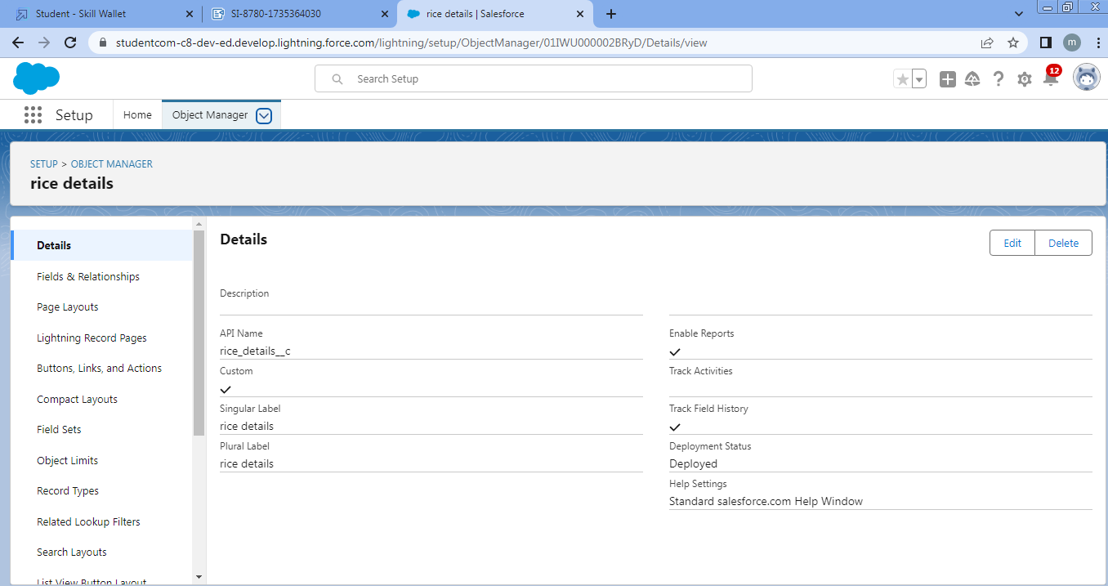

**Tabs**:

Facilitate easy navigation to access various records and objects.

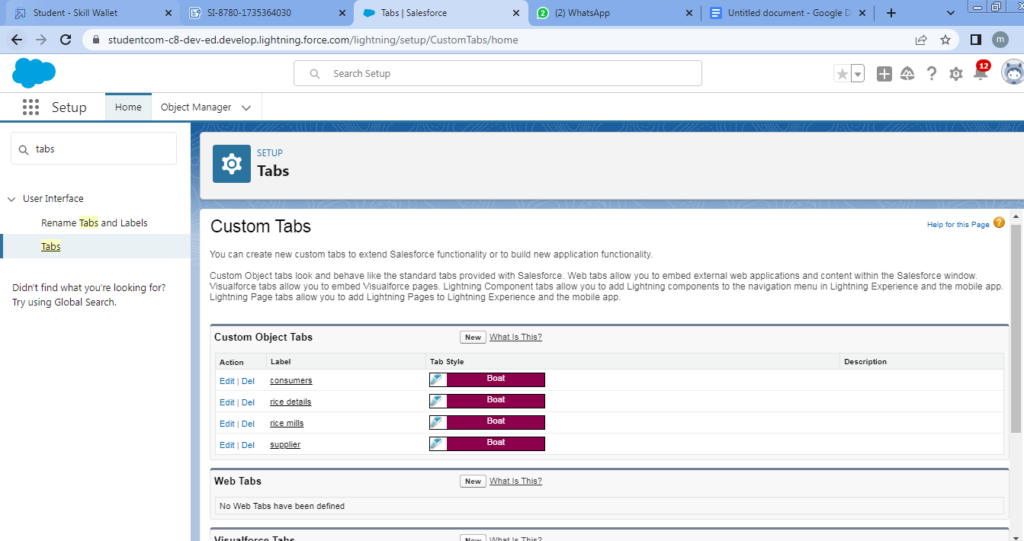

**Lightning** **App**:

Centralizes all CRM features, offering a unified interface for users.

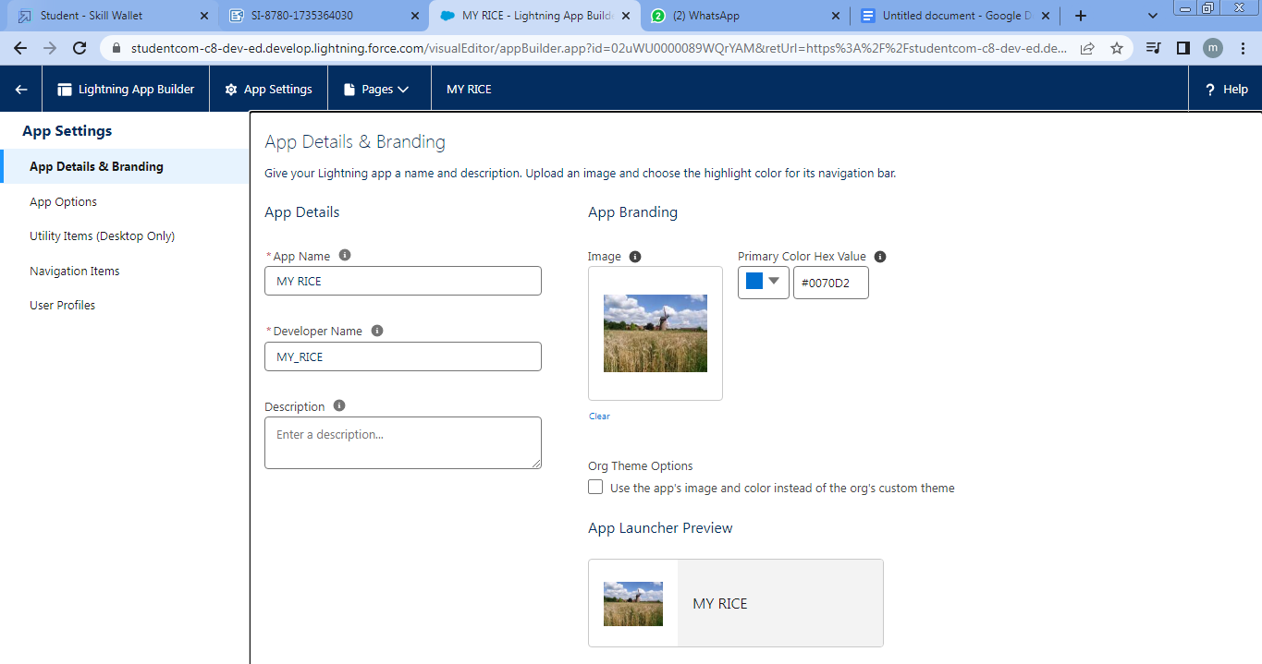

**Fields**:

Custom fields capture important data, such as quantity sold, price per kg, and total sales.

Fields are created for consumer ,rice mill ,rice details and supplier objects.

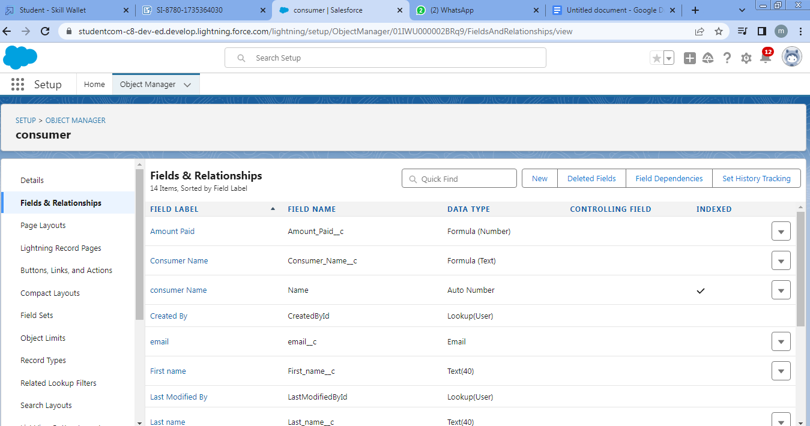

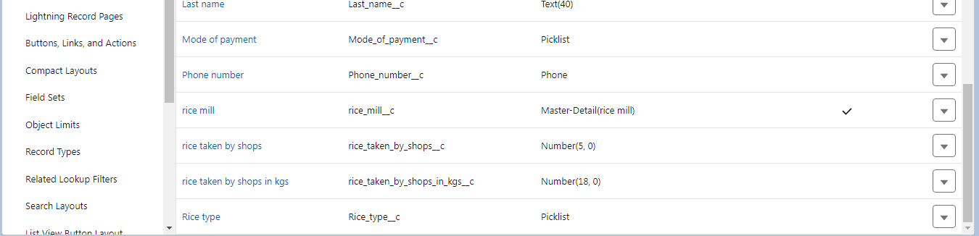

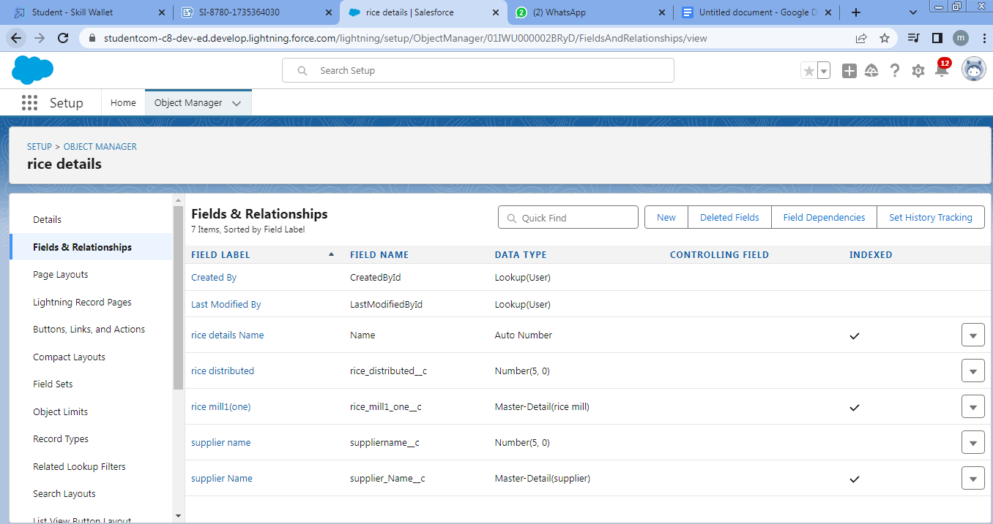

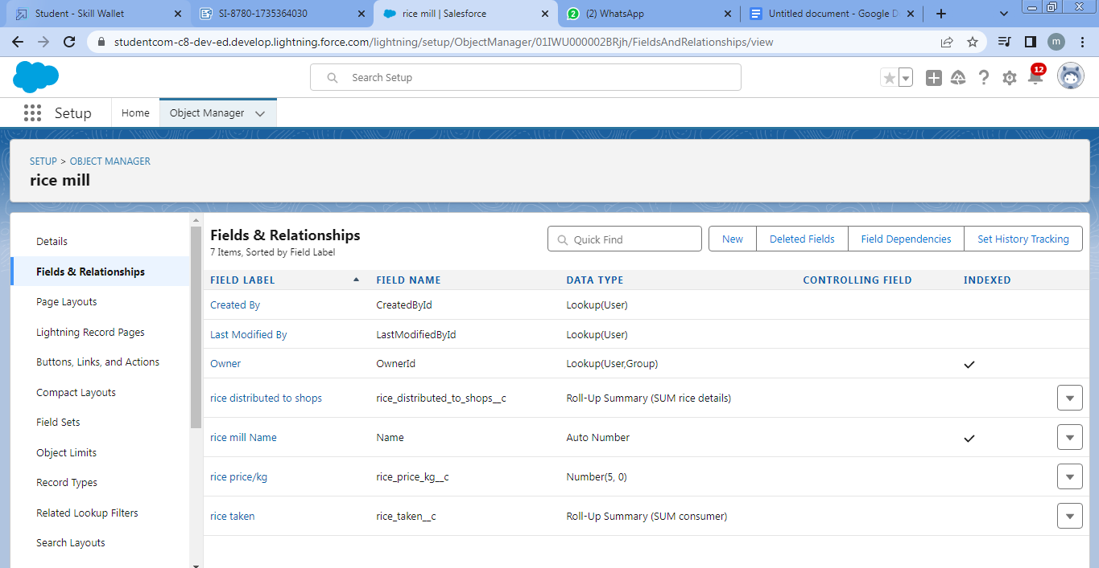

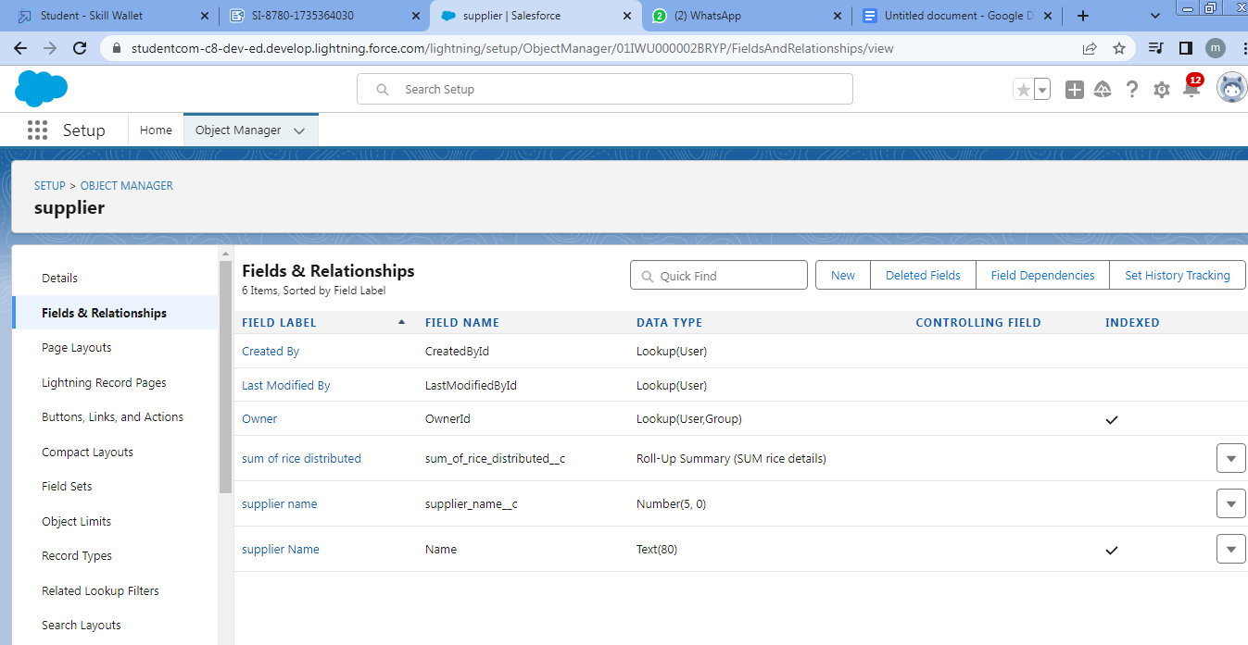

**Page Layouts:**

Organize fields and records, making them more accessible and user-friendly.

Following are the page layouts created for each object.

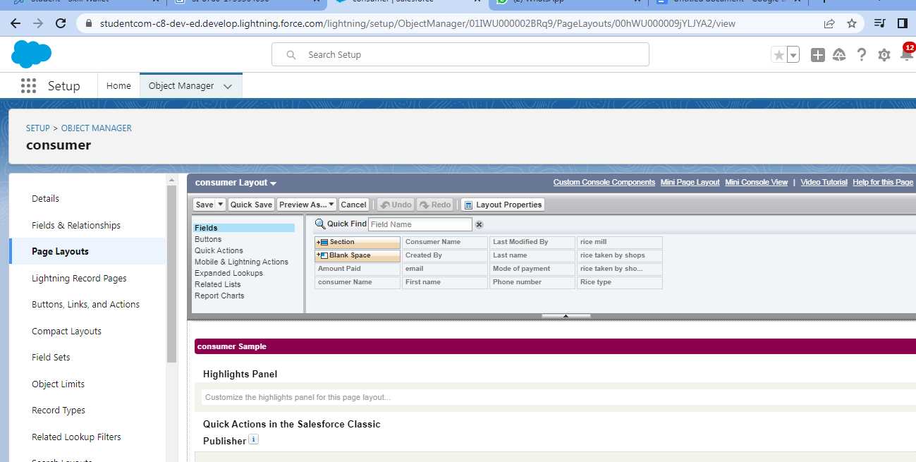

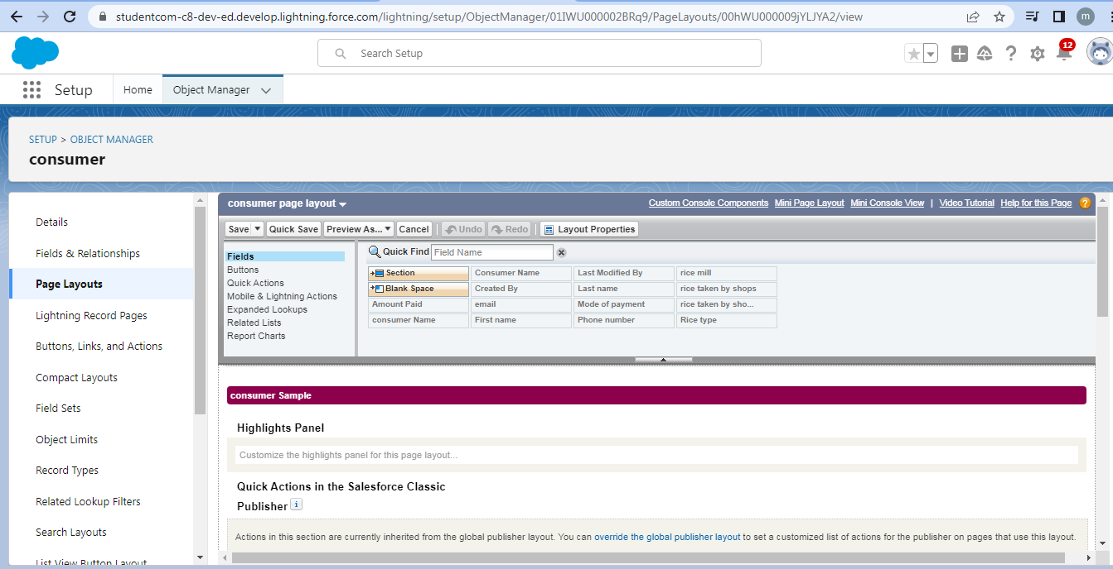

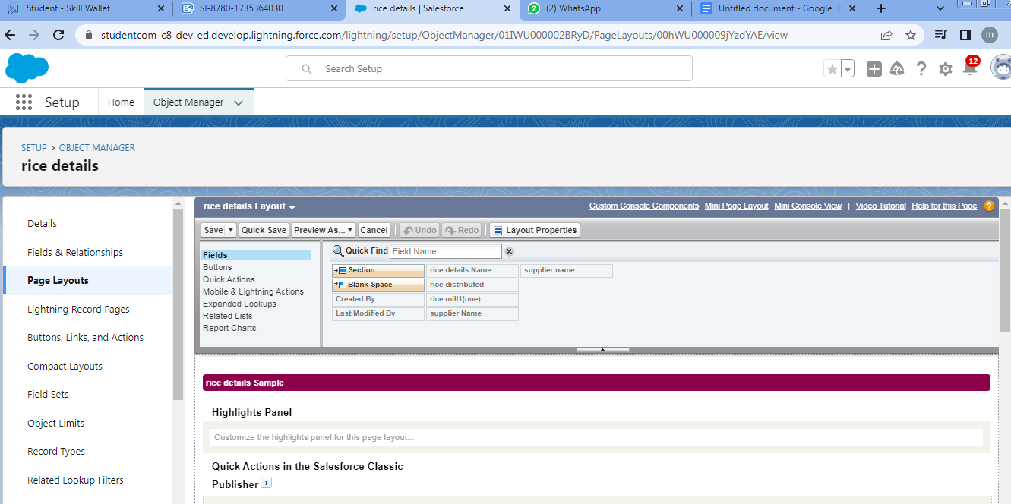

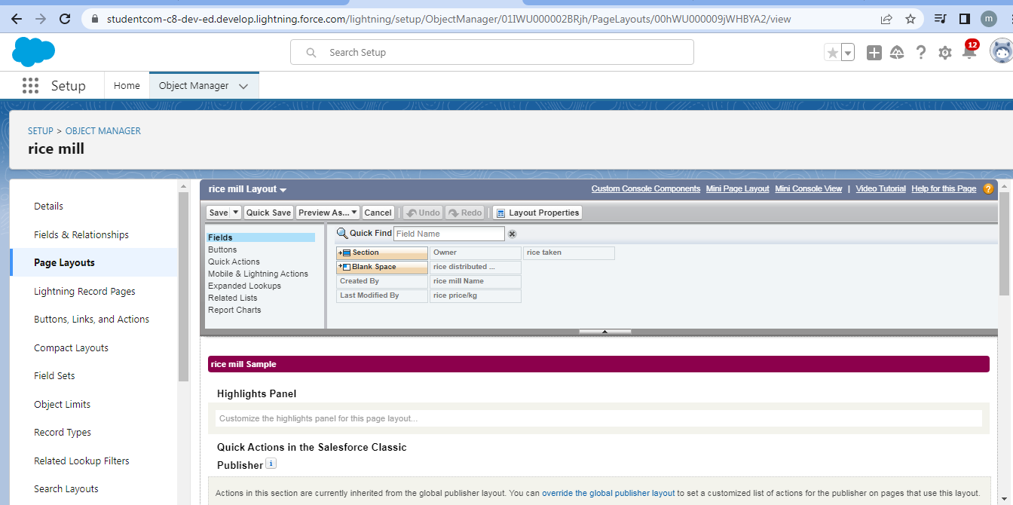

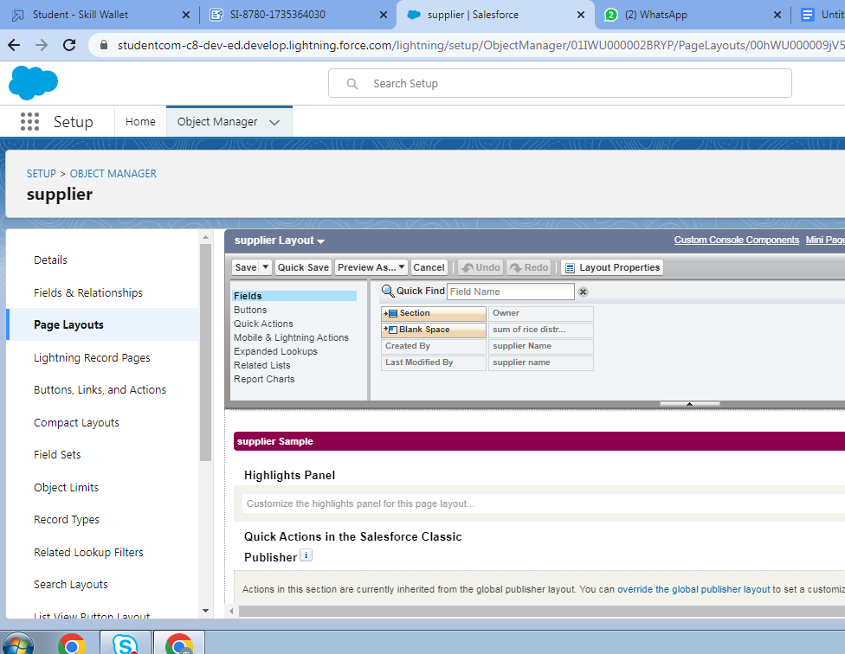

**Profiles:**

Define and control user permissions, limiting access to specific records and data.

A profile is a group/collection of settings and permissions that define what a user can do in salesforce. Profile controls “Object permissions, Field permissions, User permissions, Tab settings, App settings, Apex class access, Visualforce page access, Page layouts, Record Types, Login hours & Login IP ranges.

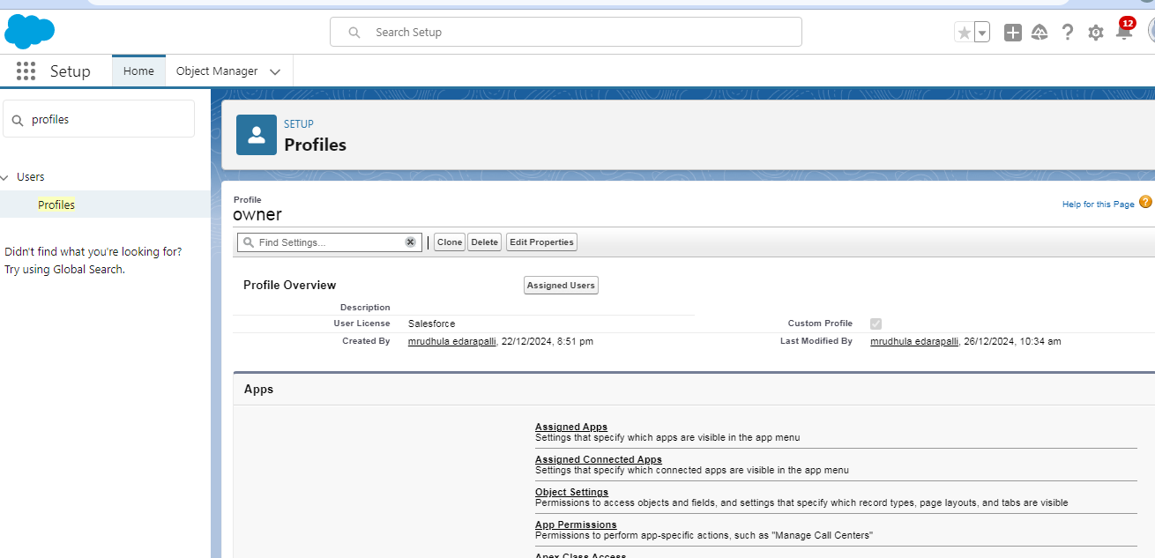

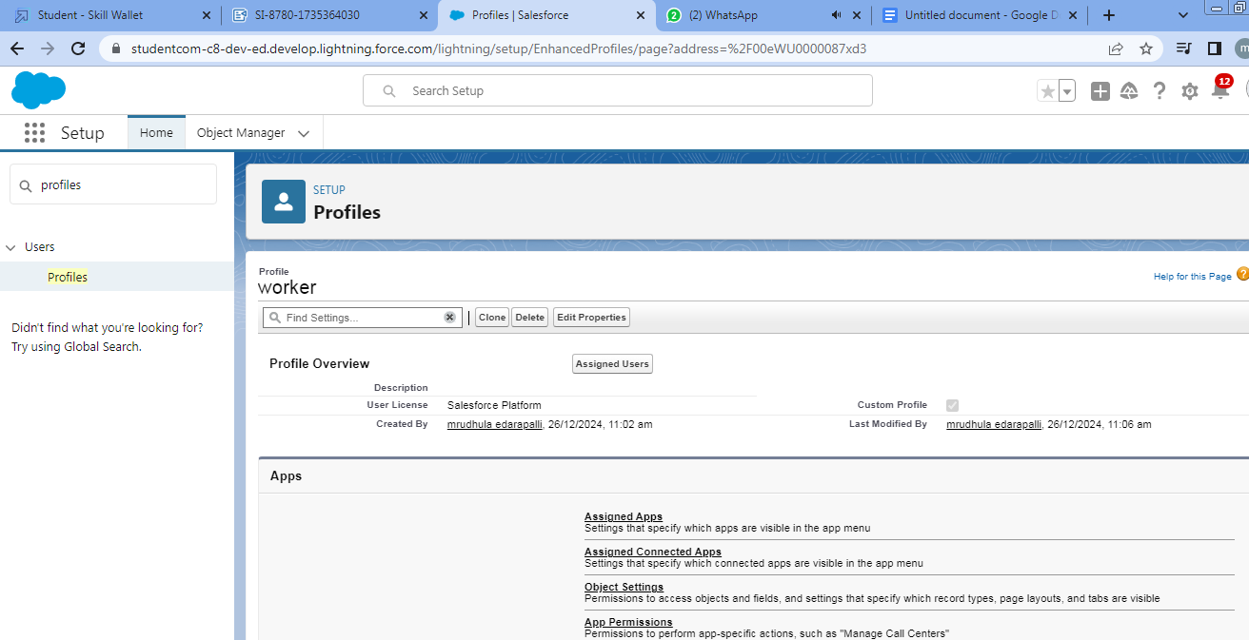

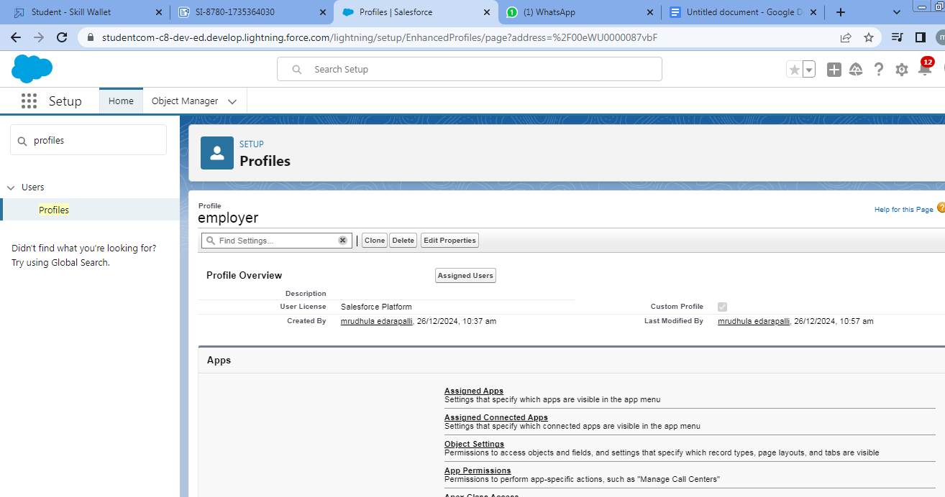

**Role & Role Hierarchy**: Determine record access levels based on the user’s role within the organization.

**Users**: Represent individuals interacting with Salesforce, each with specific roles and profiles.

**Permission** **Sets**: Allow for more granular control of user access to additional features beyond their profile.

**Reports**: Enable detailed analysis of rice sales, revenue, and customer trends.

**Dashboards**: Provide visual insights into performance metrics and overall business health.

**Apex**: Automates complex business logic and processes that go beyond standard features.

**Validation** **Rules**: Ensure the integrity of data by enforcing rules for required fields and correct entries.

**Rollup** **Summary** **Fields**: Aggregate data from child records to parent records, like total sales or total rice supplied.

**Cross**-**Object** **Formula** **Fields**: Calculate data from related objects, such as total amount due based on rice quantity and price.

These Salesforce features work together to optimize operations, automate tasks, improve data quality, and provide valuable business insights for better decision-making in the rice mill business.

**4. Detailed Steps to Solution Design**

**Requirement Gathering:**

Understand the key pain points and requirements of the wholesale rice mill business.

Document the needs related to customer management, order tracking, and sales processes.

**Data Model Design:**

Create custom objects such as Customer, Order, RiceInventory, and Supplier.

Define relationships between objects (e.g., Customers and Orders, Inventory and Orders).

**UI Design:**

Develop user-friendly Lightning pages for key entities.

Implement search functionality for quick access to records.

**Business Logic Implementation:**

Use Apex classes and triggers for custom business rules, such as inventory deduction upon order fulfillment.

Configure validation rules to ensure data accuracy.

**Automation:**

Create workflows for sending automated emails for order confirmations and delivery updates.

Use Process Builder for follow-up reminders based on order status.

**Reports and Dashboards:**

Build dashboards showing sales trends, top customers, and inventory status.

Configure real-time reports for quick insights.

**5. Testing and Validation**

**Unit Testing:**

Test Apex classes and triggers to ensure accuracy in business logic implementation.

**User Interface Testing:**

Validate the usability and responsiveness of Lightning pages across devices.

**Integration Testing:**

Verify data flows between different Salesforce components and third-party systems (if any).

**User Acceptance Testing (UAT):**

Engage end-users to test the application against real-world scenarios.

**6. Key Scenarios Addressed by Salesforce in the Implementation Project**

Efficient tracking of bulk orders and their statuses.

Maintaining accurate inventory levels with automated updates.

Generating detailed sales and customer interaction reports.

Automating repetitive tasks, such as follow-ups and confirmation emails.

Enabling mobile access for field sales teams.

Providing a 360-degree view of customer information to improve service quality.

**7. Conclusion**

**Summary of Achievements:**

Successfully implemented a customized CRM solution for wholesale rice mills using Salesforce.

Streamlined sales and order management processes.

Enhanced customer relationship management through automation and detailed insights.

Improved inventory tracking and operational efficiency.

Delivered a scalable and user-friendly system aligned with the business’s long-term goals.

**This project demonstrates the potential of Salesforce as a transformative tool for the wholesale rice mill industry, setting a strong foundation for future growth and innovation.**

